**FragAssembler tutorial**

**Table of contents**

1. **FragAssembler software workflow ------------------------------------- p.2.**
2. **Prepare the biotransformation product data of your interest parent compound for FragAssembler analysis ---------------------- p.3.**
3. **The usage of FragAssembler software --------------------------------- p.6.**
4. **References ------------------------------------------------------------------ p.10.**

**FragAssembler software workflow**

FragAssembler is an open-source cheminformatics software for elucidating the possible chemical structure of biotransformation products and reducing the number of false-positive structure candidates during the identification of xenobiotic biotransformation products. The website of FragAssembler software is <https://cosbi.ee.ncku.edu.tw/FragAssembler/> . The source code of FragAssembler can be found in <https://github.com/YuanChihChen/FragAssembler> , which also contain 12 example data in the “example data” folder. The workflow of FragAssembler software was illustrated as follow.

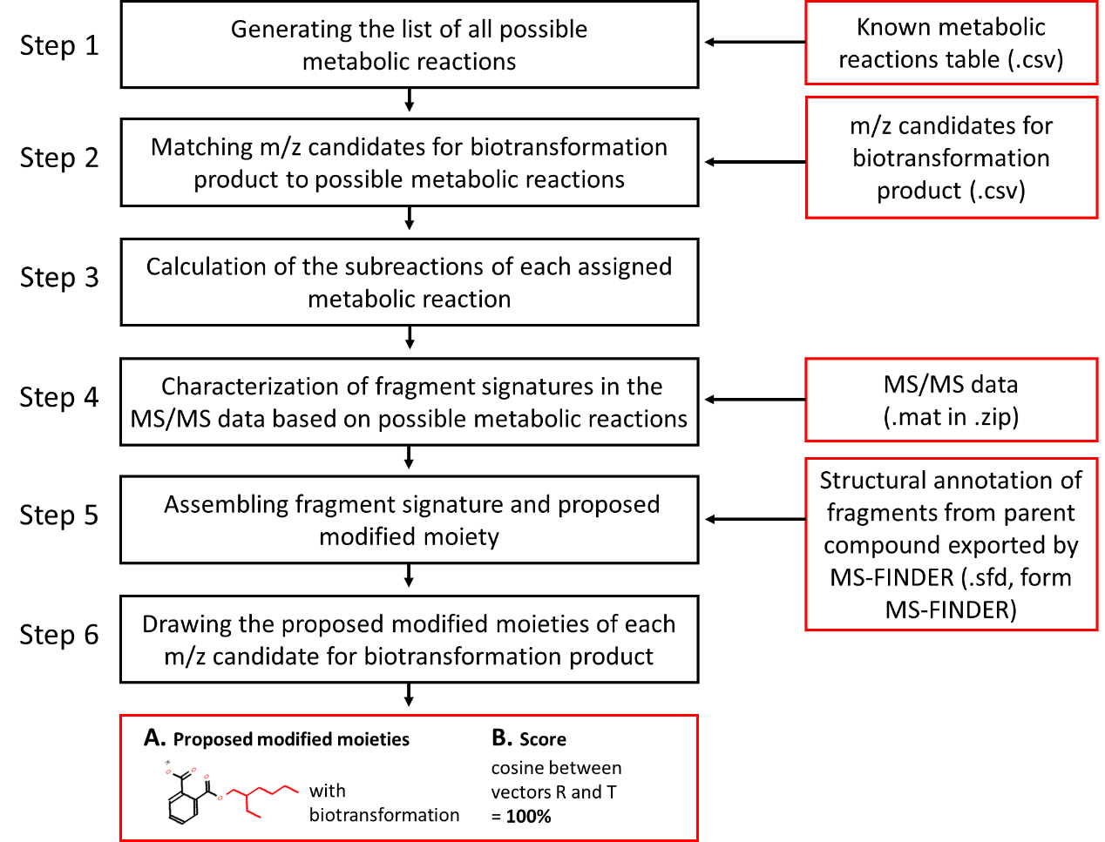

**FragAssembler consists of six processing steps.**

1. All possible metabolic reactions are generated by the known metabolic reactions table (default metabolic reactions1 or user defined metabolic reactions), molecular weight of parent compound, and setting number of successive transformations.
2. Possible metabolic reactions are assigned to each m/z candidate for biotransformation product with the setting mass error.
3. Calculation of the subreactions of each assigned metabolic reaction. For example, the metabolic reaction “hydroxylation + demethylation” can be broken down into “hydroxylation”, “demethylation”, and “hydroxylation + demethylation”.
4. Screening the mass difference between each fragment in the MS/MS data of m/z candidate and parent compound. When the mass difference matching to the mass of calculated subreactions, the matched fragments pairs would be considered as fragment signatures of the subreaction.
5. For each subreaction, fragments of the parent compound in fragment signatures are assembled. Structural identification results of these fragments exported by MS-FINDER would be intersected and generated the proposed modified moiety of each subreaction.
6. The proposed modified moiety of each subreaction were labeled on the structure of parent compound and drawn on our online viewer. The scores about the confidence of each assigned metabolic reaction are calculated based on following equation:

Factor R = [$R_{1}, R_{2}……..R_{N}]$, where N = the number of subreactions. When the subreaction k could propose modified moiety, $R_{k}= 1$, otherwise ${ R}_{k}= 0$.

Factor T = [$T_{1}, T_{2}……..T_{N}]$, For each $T_{k}$ = 1.

$$Confidence score= \frac{1}{N}\sum_{k=1}^{N}{R_{k}T_{k}}$$

If all subreactions could propose modified moieties, confidence score = 1. In contrast, confidence score = 0 when none of each subreaction could propose modified moiety.

**Prepare the biotransformation product data of your interest parent compound for FragAssembler analysis**

The calculation of FragAssembler is based on the MS/MS data of parent compound and biotransformation products. Users can design an in vitro or in vivo metabolism experiment to acquire the features and MS/MS data of the biotransformation products of the interest parent compound. For the filtering of biotransformation products, various method could be applied. The example analysis approach can refer to these reported studies2, 3. For the MS/MS data acquisition, FragAssembler needs high-quality and high-resolution MS/MS data. The liquid chromatography-high-resolution mass spectrometry (LC-HRMS), such as Q-tof and Orbitrap mass spectrometer, with data-dependent acquisition (DDA) mode or targeted MS/MS acquisition mode is recommended to acquire the high-resolution MS/MS data of interested compounds and biotransformation products.

Before input the data in to FragAssembler software, data need to be prepared into three individual files: (1). m/z candidates for biotransformation product (.csv), (2). MS/MS data for the m/z candidates of biotransformation product (.mat in .zip), and (3). Structural annotation of fragments from parent compound exported by MS-FINDER (.sfd, form MS-FINDER).

1. **m/z candidates for biotransformation product (.csv)**

The m/z candidates for biotransformation product.csv include the name of MS/MS data and *m/z* values of both parent compound and m/z candidates for biotransformation product filtered from LC-HRMS data. The creation of MS/MS data in mat format was wrote in following “2. MS/MS data for the m/z candidates of biotransformation product (.mat in .zip)” section. **It's worth noting that the MS/MS data name and *m/z* value of parent compound should be put on the top of the table and the name of MS/MS data should be added the file name “.mat”.**

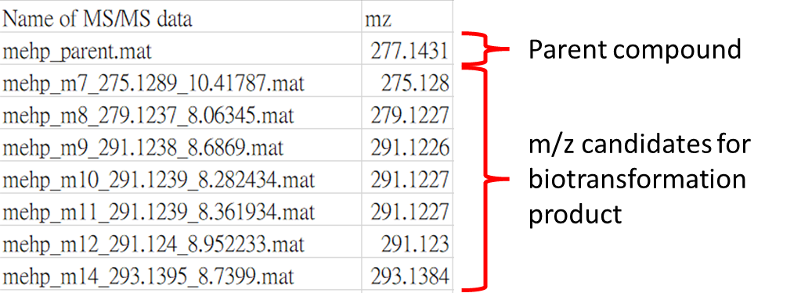

The demo of m/z candidates for biotransformation product could be downloaded in website of FragAssembler software is <https://cosbi.ee.ncku.edu.tw/FragAssembler/> .

1. **MS/MS data for the m/z candidates of biotransformation product (.mat in .zip)**

The MS/MS data of parent compound and m/z candidates for biotransformation product from LC-HRMS data are recommended to extract based on MS-DIAL (<http://prime.psc.riken.jp/compms/msdial/main.html>). In shortly, import the raw LC-HRMS and MS/MS data of metabolism experiments into MS-DIAL software for the MS1 peak picking and alignment (detail steps can see the MS-DIAL tutorial). Then following the “Section 9-5 Bulk export to MS-FINDER from peak and alignment spot table” in MS-DIAL tutorial to export all MS/MS data of raw LC-HRMS data in mat format. The exported MS/MS should be involved in a selected folder:

The MS/MS data of parent compound and m/z candidates for biotransformation product could be selected form these MS/MS data and compressed into a .zip file for FragAssembler analysis. The demo of MS/MS data could be downloaded in website of FragAssembler software is <https://cosbi.ee.ncku.edu.tw/FragAssembler/> .

1. **Structural annotation of fragments from parent compound exported by MS-FINDER (.sfd, from MS-FINDER)**

Structural annotation of fragments from parent compound needs to be inputted into FragAssembler. It is recommended to use *in silico* fragment annotation tool MS-FNDER to generate the annotation result (.sfd file). For the MS-FNDER calculation, input the MS/MS data of the parent drug (.mat format) in the MS-FNDER software and calculate the *in silico* fragment annotation result of the parent drug. If the compound structure databases incorporated in MS-FNDER did not contain the targeted parent compound, user can input the targeted parent compound following the “Section 3-5 User defined structure database format” in the tutorial of MS-FNDER.

The annotation result (.sfd file) is simultaneously generated in the folder of MS/MS data during the calculation. The location of .sfd file of parent drug could be found based on the path in the following figure. **It is worth noting that the wrong ID results in the .sfd file should be removed before input into FragAssembler software.**

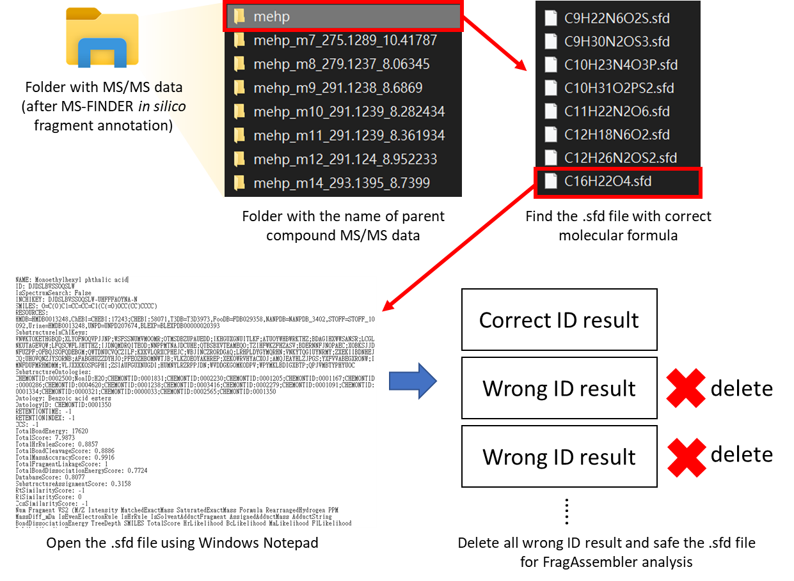

The details for using MS-FNDER software can be found at <https://mtbinfo-team.github.io/mtbinfo.github.io/MS-FINDER/tutorial>. The demo of Structural annotation of fragments from parent compound exported by MS-FINDER (.sfd, from MS-FINDER) could be downloaded in website of FragAssembler software is <https://cosbi.ee.ncku.edu.tw/FragAssembler/> .

**The usage of FragAssembler software**

1. Preparing three individual files: **(1).** m/z candidates for biotransformation product (.csv), **(2).** MS/MS data for the m/z candidates of biotransformation product (.mat in .zip), and **(3).** Structural annotation of fragments from parent compound exported by MS-FINDER (.sfd, form MS-FINDER) based on the description in section “Prepare the biotransformation product data of your interest parent compound for FragAssembler analysis” and open the website of FragAssembler software <https://cosbi.ee.ncku.edu.tw/FragAssembler/> .
2. Inputting the Known metabolic reactions table(.csv). Users can use default known metabolic reactions table or upload the user-defined known metabolic reactions table. The demo of Known metabolic reactions table could be downloaded on the right site.

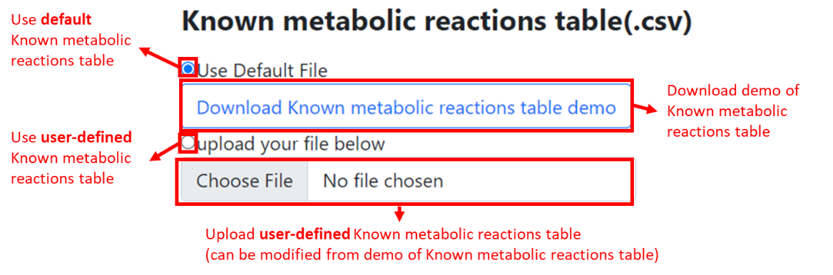

1. Uploading three individual files on FragAssembler software. The demo files of all three files can be downloaded in the website.

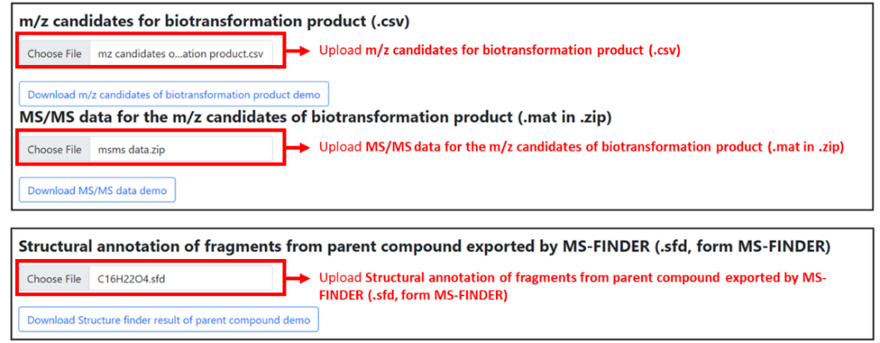

1. Setting the parameters. There have 6 parameters should be set for the FragAssembler calculation. Detail information of these parameters is illustrated in following figure.

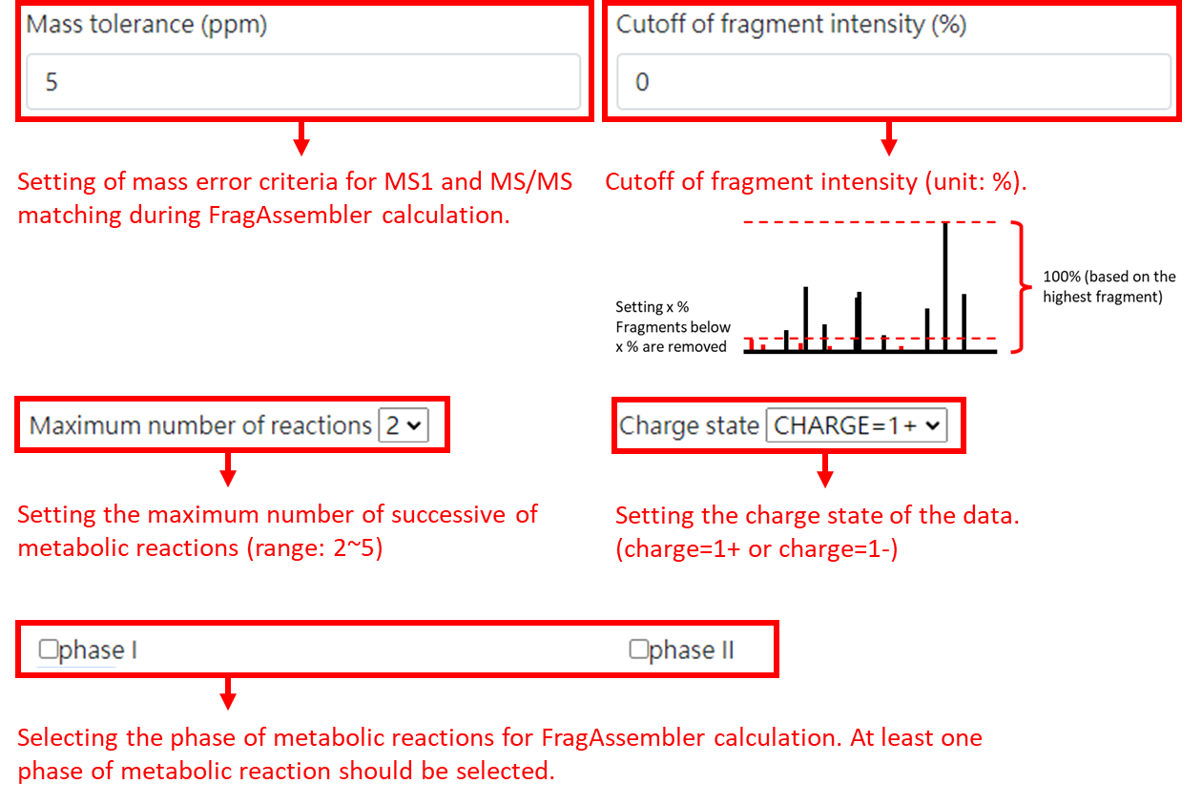

1. Press the button “send” for the FragAssembler calculation.
2. The calculation result will be displayed on the website. The explanation of each part on the “structure table” could be found in following figure.

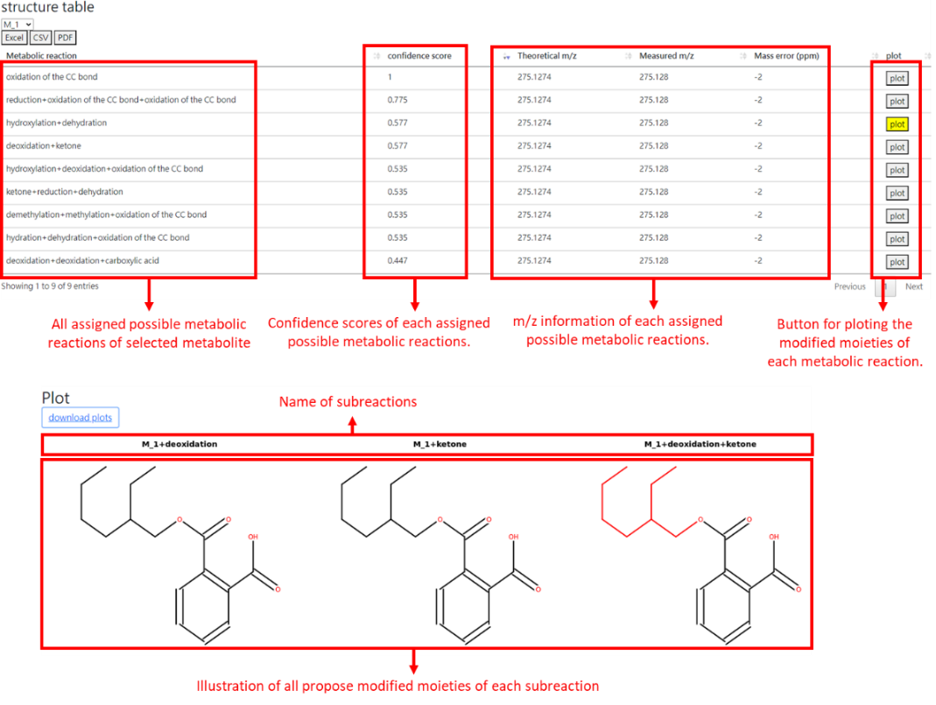

1. Using the pull-down menu can select the calculation result of each metabolite. The M1~Mx number is based on the order in m/z candidates for biotransformation product table (without parent compound).

1. The “structure table” of selected metabolite would show on the website. The order of “structure table” is based on confidence scores.
2. Press the “Plot” button of interest metabolic reaction of the selected metabolite can draw all propose modified moieties of each subreaction.

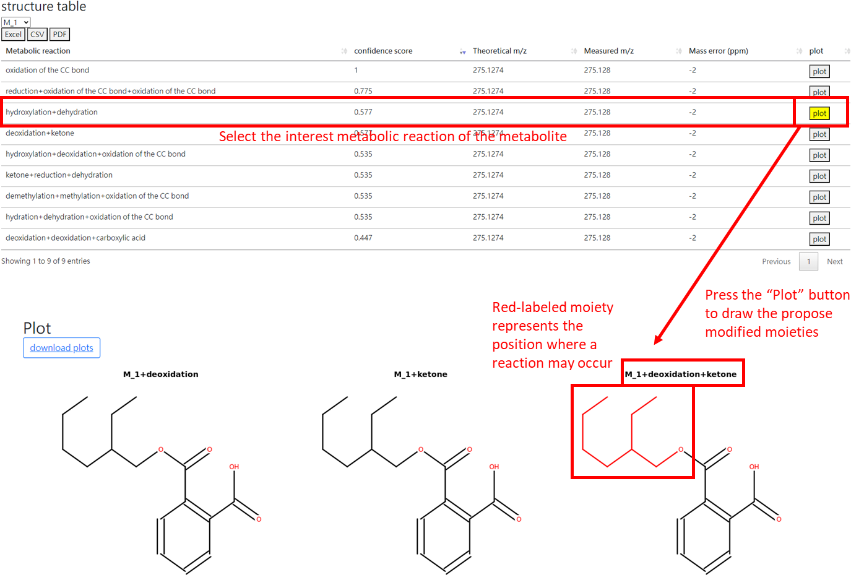

1. Both “structure table” of each metabolite and proposed modified moieties of each metabolic reaction could be downloaded from website.

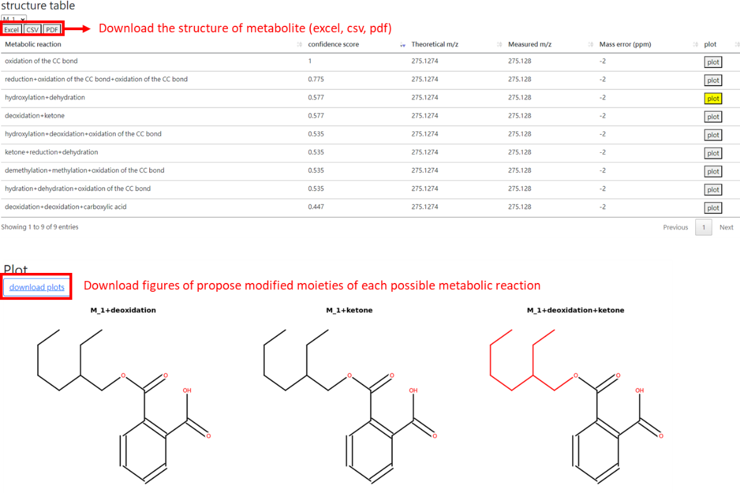

**References**

1. Delcourt, V.; Barnabé, A.; Loup, B.; Garcia, P.; André, F.; Chabot, B.; Trévisiol, S.; Moulard, Y.; Popot, M.-A.; Bailly-Chouriberry, L., MetIDfyR: An open-source r package to decipher small-molecule drug metabolism through high-resolution mass spectrometry. *Analytical Chemistry* **2020,** *92* (19), 13155-13162.

2. Wu, H.-Y.; Chen, Y.-C.; Hsu, J.-F.; Lu, H.-T.; Pan, Y.-Y.; Ma, M.-C.; Liao, P.-C., Untargeted metabolomics analysis assisted by signal selection for comprehensively identifying metabolites of new psychoactive substances: 4-MeO-α-PVP as an example. *Journal of Food and Drug Analysis* **2023,** *31* (1), 137-151.

3. Hsu, J.-F.; Tien, C.-P.; Shih, C.-L.; Liao, P.-M.; Wong, H. I.; Liao, P.-C., Using a high-resolution mass spectrometry-based metabolomics strategy for comprehensively screening and identifying biomarkers of phthalate exposure: Method development and application. *Environment international* **2019,** *128*, 261-270.